**ASP_ASSIGNMENT**

* NAME: RATHOD JAGDEVSINH N.
* EN NO:240823075
* DIV:Z2
* *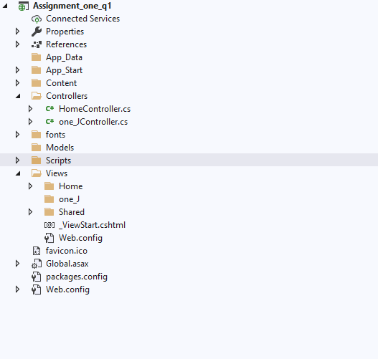Assignment_one_q1*

* *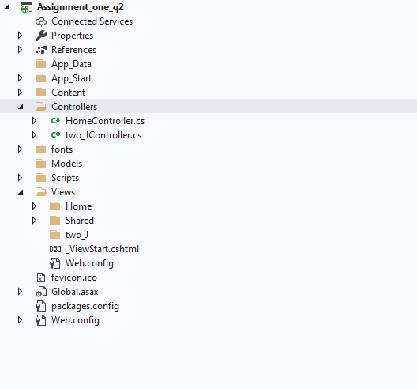Assignment_one_q2*

* *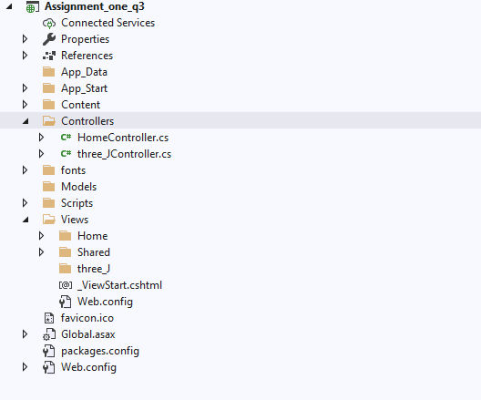Assignment_one_q3*
* *Assignment_one_q4*

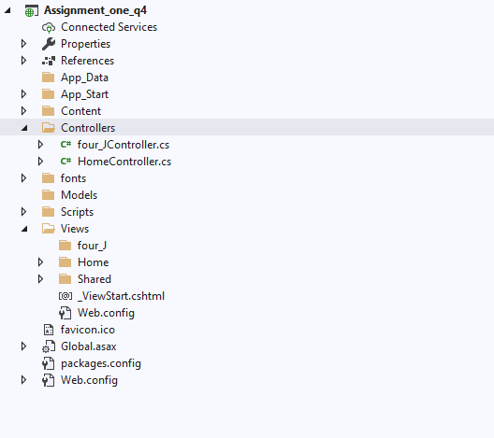

* *Assignment_one_q5*

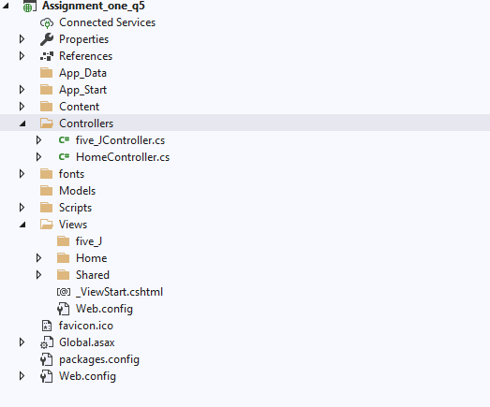

* *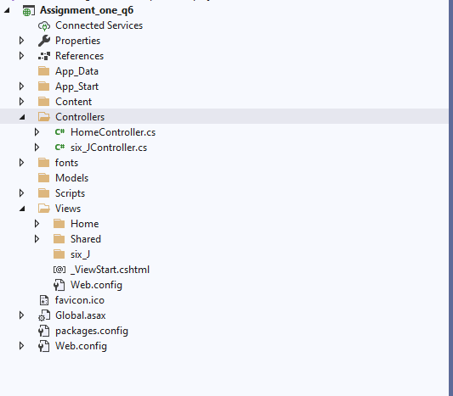Assignment_one_q6*

* Assignment_one_q7

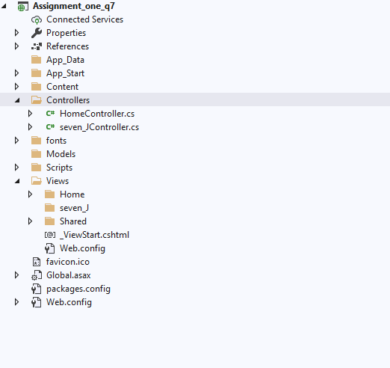

* *Assignment_one_q8*

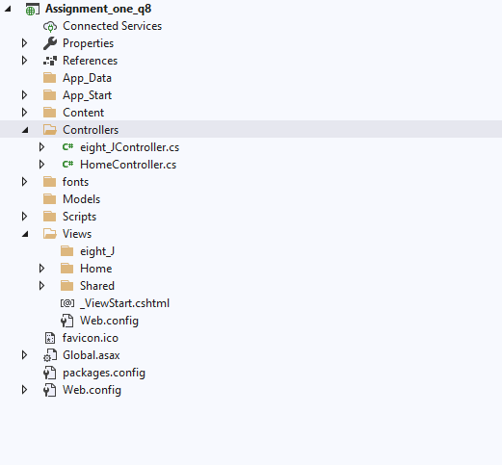

* *Assignment_one_q9*

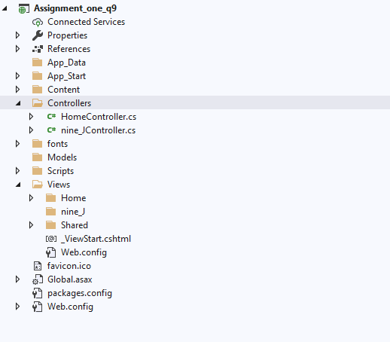

* *Assignment_one_q10*

